**Solid State Chemistry: Electrical Properties of Materials**

Intermolecular forces and thermal energy are the two factors on which physical states of matter depend. While the intermolecular forces of attraction tend to keep the particles closer; the thermal energy tends to keep the particles apart from each other by making them move faster. When the net resultant of these two opposing forces, i.e. intermolecular forces and thermal energy, makes the particles stick together and forces them to occupy fixed positions, matters exist in solid state.

Classification of solids – Solids can be classified into two types on the basis of the arrangements of their constituent particles (atoms, molecules or ions). These two types are Crystalline Solid and Amorphous Solid.

Crystalline Solid: Solids having large number of crystals; each with definite characteristic geometrical shape; are called crystalline solids.Crystal of NaCl, Quartz, Ice, Iron, etc. are some examples of crystalline solid.

Amorphous Solid: Solids having irregular shapes of particles are known as Amorphous Solids. The structures of amorphous solids are similar to that of liquids. Glass, rubber, plastics, etc. are some of the examples of amorphous solids.

**Crystal Lattices and Unit Cells**

The geometric arrangement of constituent particles(atoms, molecules, ions) of crystalline solids as point in space is called crystal lattice.Each constituent particle is represented by one point in a crystal lattice.These points are known as lattice point or lattice site.Lattice points in a crystal lattice are joined together by straight lines.By joining the lattice points with straight lines the geometry of the crystal lattice is formed.

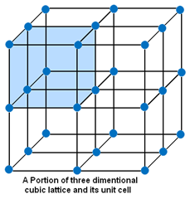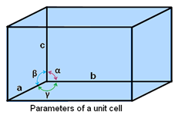

Unit Cell – The smallest portion of a crystal lattice is called Unit Cell. By repeating in different directions unit cell generates the entire lattice.

Parameters of a unit cell:

* A unit cell is characterized by six parameters. These parameters are three edges (a, b and c) and angles between them (α, β and γ).
* Dimensions along the edges of a unit cell is represented by a, b and c.
* Edges of unit cell may or may not be mutually perpendicular.
* The angle between b and c is represented by α, between a and c by β and between a and b by γ.

Types of Unit Cell: - There are two types of unit cells – Primitive and Centred Unit Cells.When particles in unit cell are present only at the corners, it is called the *primitive unit cell*.When particles are present at other positions in addition to those at corners in a unit cell, it is called a *Centred Unit Cell*.There are three types of Centred Unit Cell:

(a) Body Centred Unit Cells: – If one constituent particle lies at the centre of the body of a unit cell in addition to the particles lying at the corners, it is called Body-Centred Unit Cell.

(b) Face-Centred Unit Cells: – If one constituent particle lies at the centre of each face besides the particles lying at the corner, it is known as Face-Centred Unit Cells.

(c) End-Centred Unit Cell: – If one constituent particle lies at the centre of any two opposite faces besides the particles lying at the corners, it is known as End-Centred Unit Cell. It is also known as base-centred unit cell.

There are seven types of unit cell formed. These are **Cubic, Tetragonal, Orthorhombic, Monoclinic, Hexagonal, Rhombohedral or Trigonal and Triclinic**.

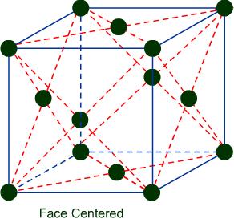Cubic Lattice – There are three types of lattice possible for cubic lattice.Primitive or Simple, Body centred, Face centred lattices. In these types of lattices all sides are of equal length. The angles between their faces are 900 in a cubic lattice.

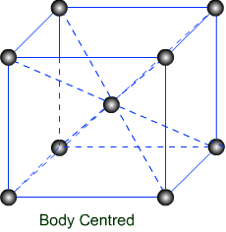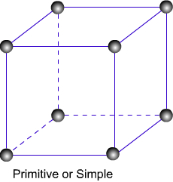

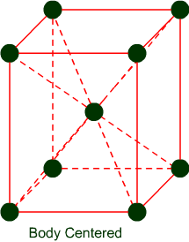Tetragonal Lattice – There are two possible types of tetragonal lattices. Primitive and Body centred unit cells. In these lattices one side is different in length and angles between faces are equal to 900.

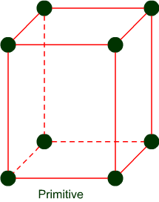

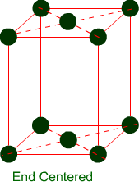Orthorhombic Lattice – Four types of orthorhombic lattice are possible. They are Primitive, End-centred, Body centred and Face centred. They have unequal sides. The Angles between their faces are equal to 900.

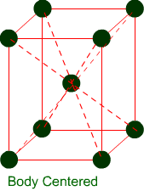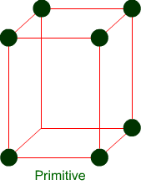



Monoclinic Lattice – There are two possible types of monoclinic lattice. They are Primitive and End centred. They have unequal sides and two faces have angles other than 900.

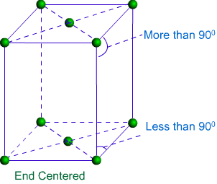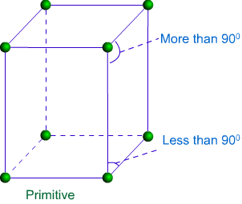

Hexagonal lattice – Hexagonal lattice is of one type only. It has one side is different in length to the other two and the angles on two faces are 600.

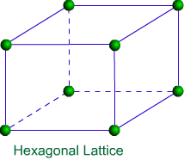

Rhombohedral Lattice – Only one type of lattice is possible for Rhombohedral lattice. It has all sides equal and angles on two faces are less than 900.

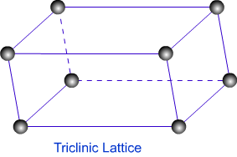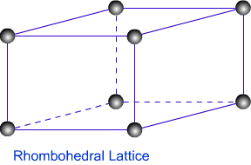

Triclinic Lattice – Triclinic lattice has only one type of lattice. It has unequal sides and none of the angles between faces are equal to 900.

**Close Packed Structure**

Matters exist in solid state because of close packing of their constituent particles. There are two types of close packing found in solids. These are Cubic Close Packed (ccp)and Hexagonal Close Packed (hcp) lattice.

Cubic Close packed (ccp):

In this type of packing, the spheres of molecules are adjacent to each other that each row of spheres in a particular dimension is a repetition of the pervious row. The spheres of a particular row don’t fit in the depressions between two adjacent spheres of the previous row. This types of arrangement is called AAAA type arrangement. This is also known as face centered cubic (fcc). This type of close packing of constituent particles is found in metals like copper, silver, etc.

Lattice of this cubic close packed is simple cubic and its unit cell is primitive cubic unit cell.

Hexagonal Close packed (hcp):

In this type of packing, the spheres of molecules of a particular row in a particular dimension are in a position that they fit into depressions between adjacent spheres of the previous row. This type of arrangement is called ABAB type arrangement. This type of packed lattice is found in many metals such as magnesium, zinc, etc.

Coordination number: The number of adjacent particles of atoms is called coordination number.

In both ccp and hcp, each sphere is surrounded by 12 adjacent atoms, thus coordination number is equal to 12 in each case. The packing efficiency (volume of space occupied by the spheres/total volume) is 74.05 % (highest average density) for both cubic and hexagonal close packing schemes.

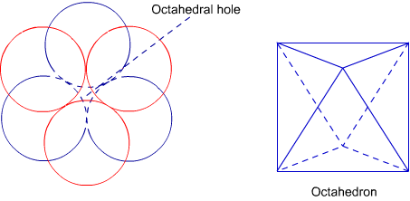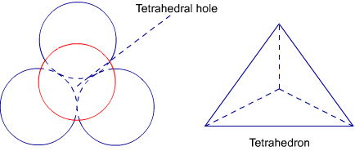Formation of voids in close packing:Empty space left after the packing is called void. Two types of voids are formed in ccp and hcp structures. These are tetrahedral voids and octahedral voids. Tetrahedral voids are formed because of formation of tetrahedron between the layers of atoms. Thus, voids in the shape of tetrahedron are called tetrahedral voids.Octahedral voids are formed because of formation of octahedron between the layers of atoms. Thus, voids in the shape of octahedron are called octahedral voids.

**Imperfections in Solids or Crystal defects**

Irregularity in the arrangement of constituent particles in solids is called crystal defect or imperfection in solids. There are two types of crystal defects - **Point Defects** and **Line Defects**. Irregularities or deviation from ideal arrangement of constituent particles around the point or atom in a crystalline solid is known as *point defects*. Irregularities or deviation from ideal arrangement of constituent particles in entire row of lattice is known as *line defects*.

**Electrical Properties**

Solids show amazing range of electrical conductivities. Electrical conductivity is the reciprocal of resistivity. The SI unit of resistivity is ohm meter. Whereas resistivity is the property of solids to resist flow of electricity, conductivity is the property to conduct electricity. The SI unit of conductivity (σ)is ohm-1m-1.

**THE BAND THEORY OF CONDUCTIVITY**

The band theory is the result of the application of molecular orbital theory (MOT) to metals and explains conduction in metals. According to MOT, all atomic orbitals participating in molecule formation combined to form equal number of molecular orbitals having definite energy levels.In solids, permitted electron energy levels are named as **bands**. The band containing the valence shell electrons (3s for Na) is called the [**valence band**](javascript:locategloss('v')). Any band that is either vacant or partially filled is called a [**conduction band**](javascript:locategloss('c')).

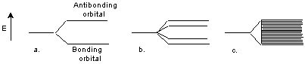

Figures above explain the formation of an energy band by the successive overlap of atomic orbitals. (a) When the two atomic orbitals of two atoms overlap, one bonding orbital and one antibonding orbital of significantly different energies are formed. (b) When four atomic orbitals of two atoms overlap, four molecular orbitals are formed. (c) With so many orbitals, the orbital energies differ very small from each other and form a virtually continuous band.

For example, conduction in Na metal: When a voltage is applied across a piece of sodium metal, conduction occurs. The current is the result of electrons in the 3s band being free to jump from atom to atom. In alkali metals the conduction band and the valence band are the same. The orbitals within the band are so similar in energy that an electron does not need to gain appreciable energy to reach the conduction band.

Metals are **conductors**. There is no band gap between their valence and conduction bands, since they overlap.  There is a continuous availability of electrons in these closely spaced orbitals.

In an [**insulator**](javascript:locategloss('i')), such as glass or plastic, the valence band is filled. Thus the next vacant higher-energy band becomes the conduction band. An energy gap exists between the valence band and the conduction band. This large separation prevents electrons in insulators from entering the conduction band.

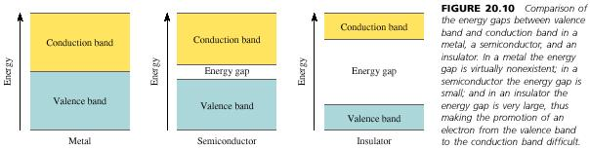

A [**semiconductor**](javascript:locategloss('s')), such as Si and Ge, has a filled valence band and an empty conduction band, but in contrast to an insulator, a relatively small gap exists between these bands. A relatively small amount of thermal energy will promote an electron into the conduction band. Thus as temperature increases, the conductivity of semiconductors increases. There are two different kinds of semiconductors: **intrinsic** and**extrinsic**.

An **intrinsic semiconductor** is a semiconductor in its pure state. For every electron that jumps into the conduction band, the missing electron will generate a hole that can move freely in the valence band. The number of holes will equal the number of electrons that have jumped.

In **extrinsic semiconductors**, the band gap is controlled by purposefully adding small impurities to the material. This process is called **doping**. Doping or adding impurities to the lattice can change the electrical conductivity of the lattice and therefore vary the efficiency of the semiconductor. In extrinsic semiconductors, the number of holes will not equal the number of electrons jumped.

Silicon or germanium is doped with electron rich impurities to increase their electrical conductivity. Semiconductors so formed after are called n-type semiconductors. When silicon or germanium is doped with elements, such as Boron, Aluminium or Gallium, semiconductor thus formed with electron deficient impurities; are called p-type semiconductors.Doping with electron rich or electron deficient elements creates electronic defects in semiconductors.

Applications of n-type and p-type semiconductors:

* Both n-type and p-type semiconductors are used in making electronic components.
* As diode which is the combination of n-type and p-type semiconductors.
* As integrated circuit (ICs).
* In photoelectric cell
* As transistors, to amplify radio and audio signal

**Summary of band theory**

* In solids, permitted electron energy levels are named as **bands**.
* The **valence band** contains electrons that can be considered to be bound to the atom. In insulators and semiconductors the valence band is full.
* The **conduction band** is a region of permitted energy levels that is empty in insulators and semiconductors, but partially filled in conductors.
* Only partially filled bands may permit conduction.
* There is a forbidden zone that forms an **energy gap** between the valence and conduction bands in insulators and semiconductors.
* That energy gap must be jumped if an electron is to move to the conduction band, and this is not normally possible in insulators because the gap is too large.
* In semiconductors, the forbidden zone is much smaller and electrons can jump the gap to the conduction zone as a result of thermal excitation.
* **Doping** of semiconductors can significantly reduce the width of the energy gap.

Magnetic Properties:

Substance shows magnetic properties because of presence of electrons in them. Each electron in an atom behaves like a magnet because of its two types of motions - one is around their axis and other around the nucleus. Electrons in an atom because of charge over them and in motion continuously; possess small loop of current which shows the magnetic moment.

Substances are classified on the basis of magnetic properties into: (1) Paramagnetic, (2) Diamagnetic, (3) Ferromagnetic, etc.

Substances show **paramagnetism** because of presence of unpaired electrons. These unpaired electrons are attracted by magnetic field.For example O2, Cu2+, Fe3+, Cr3+, Magnesium, molybdenum, lithium, etc.

**Diamagnetic** substances are just opposite to that of paramagnetic.Substances show diamagnetic property because of presence of paired electrons and no unpaired electron. Thus, pairing of electrons cancel the magnetic property.For example; H2O, NaCl, C6H6, etc.

Substances that are attracted strongly with magnetic field are called **ferromagnetic** substances, such as cobalt, nickel, iron, chromium oxide, etc.

Metals crystallise in one of three systems:  
Hexagonal close packed (hcp). 12:12 coordination. ABAB layers.  
Cubic close packed(ccp). 12:12 coordination. ABCABC layers.  
Body centred cubic (bcc) 8:8 coordination. Face centred cubic (fcc) is just an alternate name for ccp.